Secondary Lymphoedema Case Study 2

- 20 year old TB x ID mare, suffering from lymphoedema stage 3 to off hind, after third bout of lymphangitis.
- Lameness issue (especially in trot) as well as resting of the oedematous limb.
- Oedema very fibrotic, rub wounds, mud fever, de-lamination of hoof wall.
- Limb reduction after Combined Decongestive Therapy was 93% down to 21% in the first instance, and maintained after treatment at 0%.
Before photos
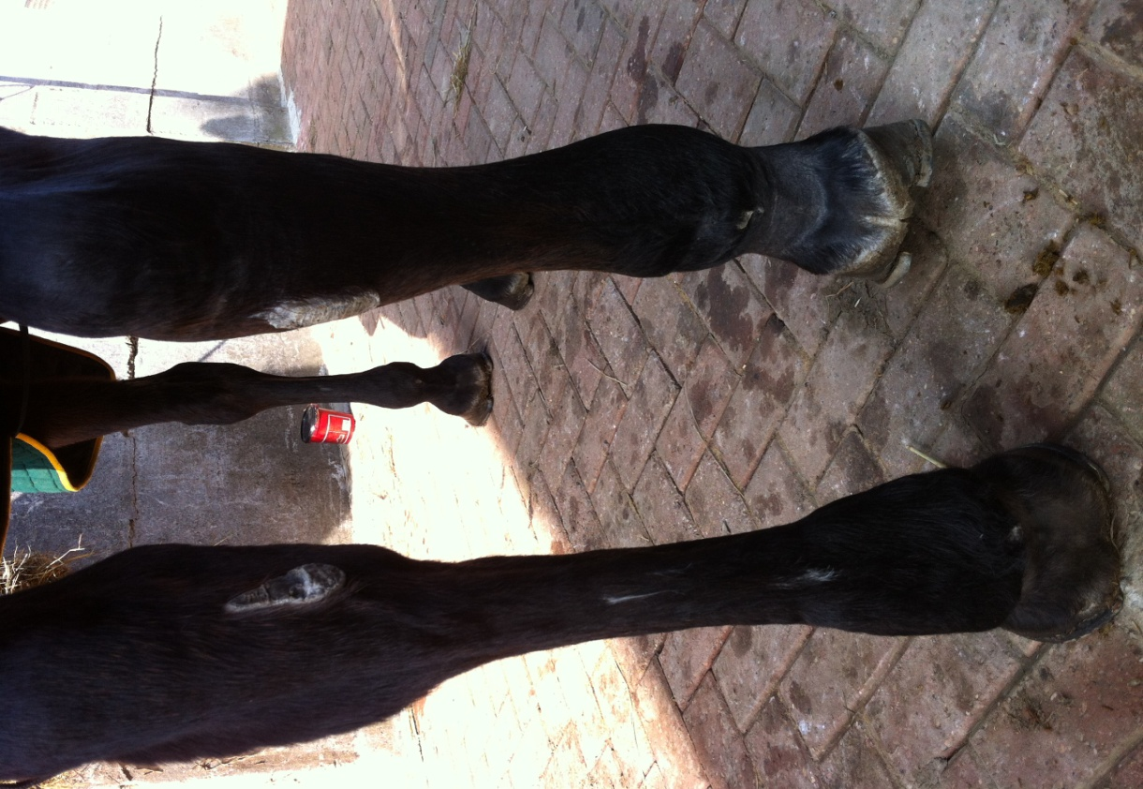

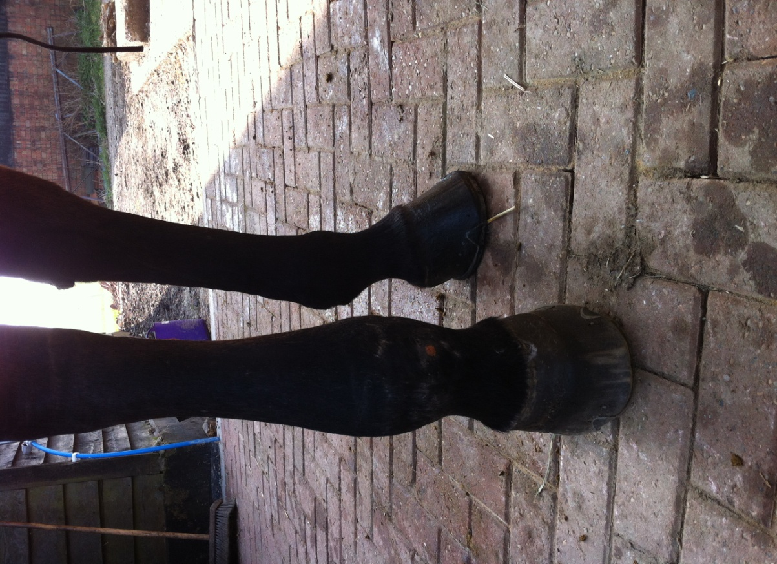

After photos
