Secondary Lymphoedema Case Study 3

Chestnut mare presenting with lymphoedema after multiple instances of lymphangitis, some so severe that the infection had caused the skin to break open. Chronic lymphorrhea, coat loss, and wound maceration.
Protein fibrosis and scar tissue, together with the longstanding nature of the disease meant this was an especially challenging case.
Started with an excess volume of 135%, and maintained in compression at 35% after treatment.

Before photos
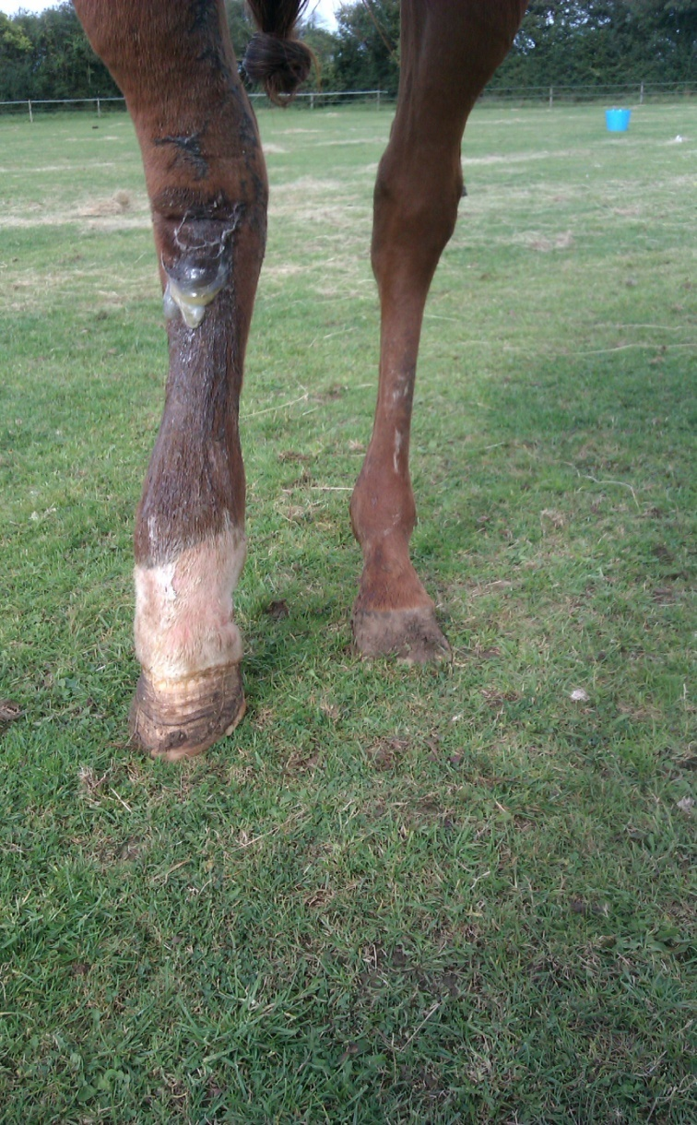

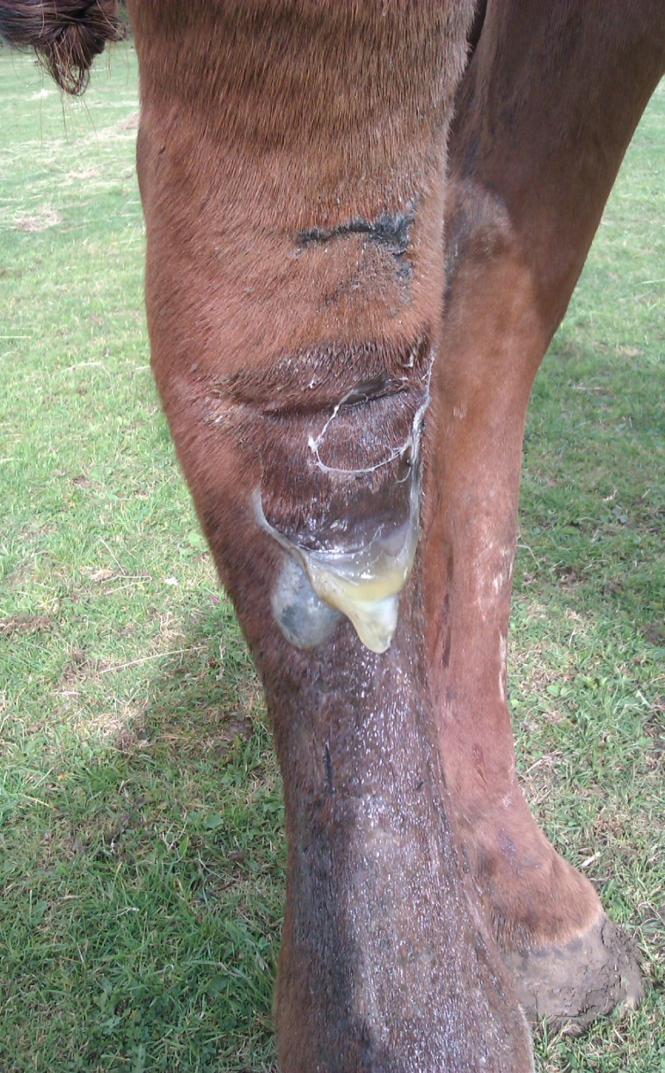

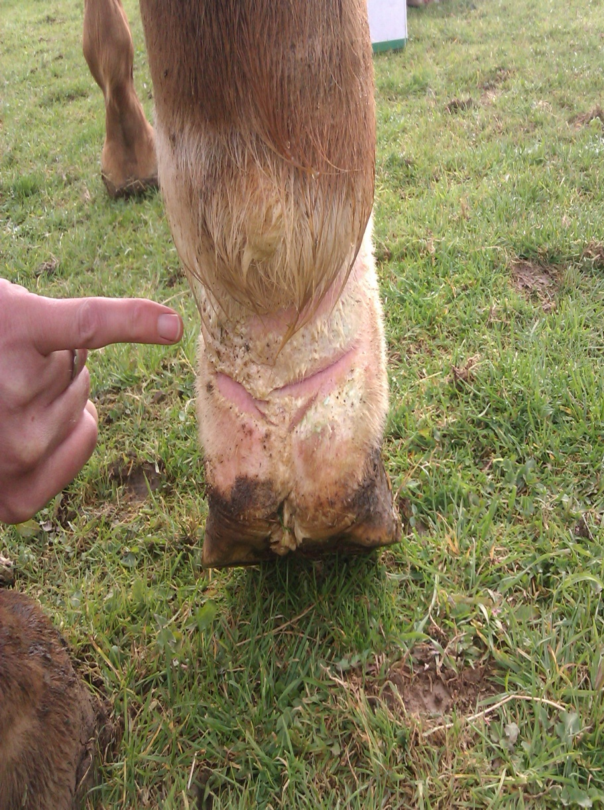

Showing extent of scarring from previous infections

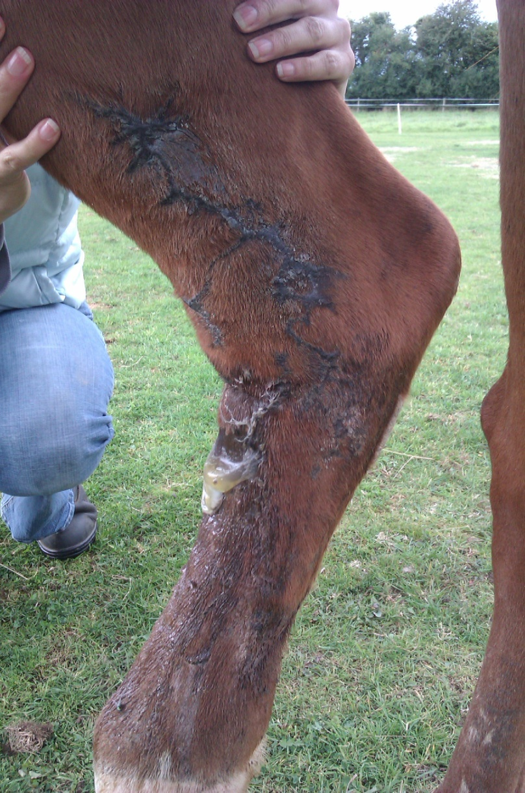

During treatment

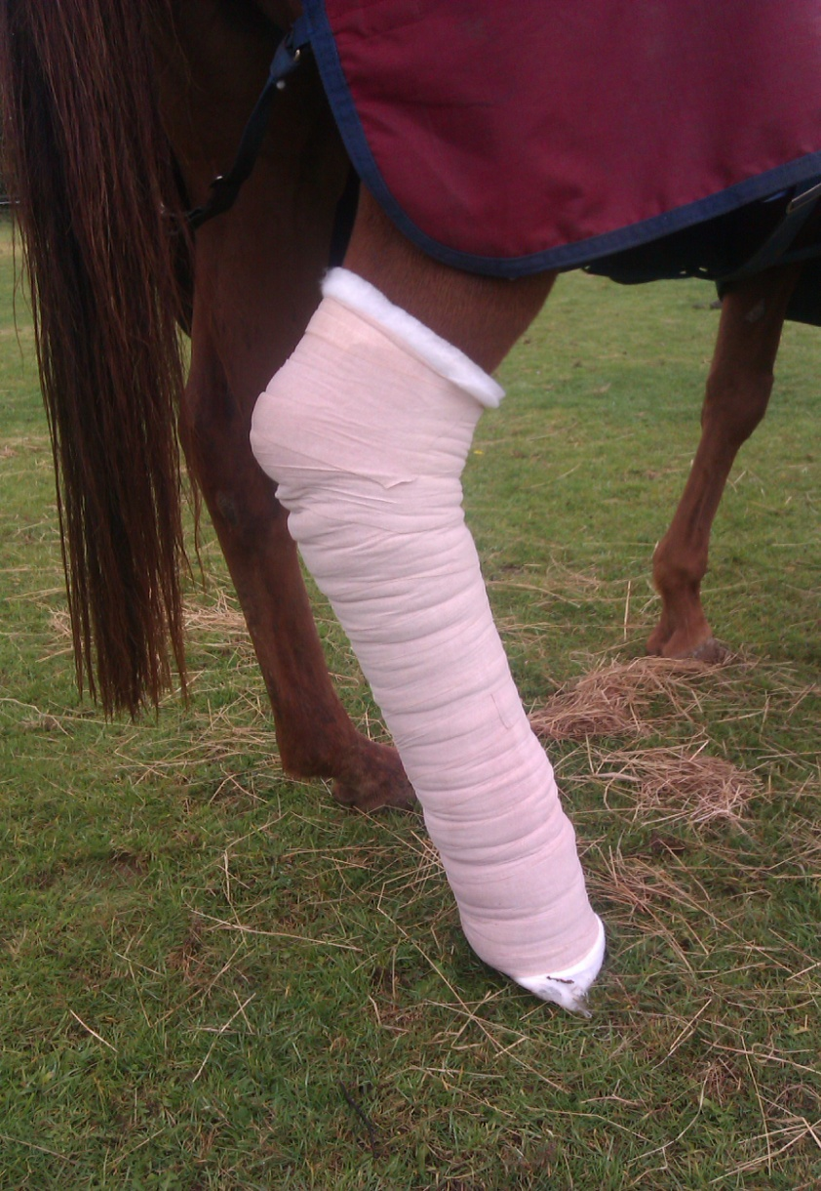

After treatment
